CASE STUDY

$32,000 in Revenue
in Just 60 Days
How a Full-Stack Marketing Strategy Transformed a
Home Service Blinds Company’s Growth

$32,000  Revenue Generated |  | 55+  Qualified Leads |  | 11.9x  Return on Ad Spend

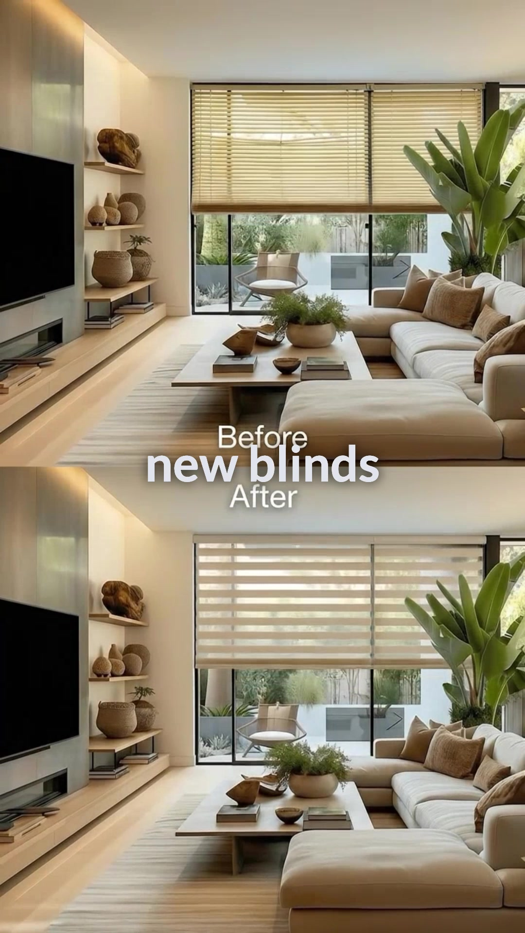 |  | INDUSTRY  Home Services — Blinds & Window Treatments  SERVICES PROVIDED  Meta Ads Management • Video Ad Creative  Before/After Carousels • Lead Forms • Multi-Hook Testing  TIMEFRAME AD SPEND  60 Days $2,683

01
The Challenge
This home service blinds company was generating leads through word-of-mouth and referrals alone. While the quality of their work was excellent — custom blinds, professional installation, and premium materials — they had no predictable lead generation system and no paid advertising strategy in place.
They needed a scalable, measurable way to reach new homeowners and generate consistent appointments for in-home consultations.

No Paid Advertising  Relied entirely on word-of-mouth and referrals for new business. | No Lead Tracking  No system for measuring marketing ROI or tracking lead sources. | Unpredictable Revenue  Inconsistent month-to-month income with no pipeline visibility.

02
The Strategy
We built a full-stack marketing system designed to generate, qualify, and convert leads through Meta (Facebook & Instagram) advertising with a multi-creative, multi-hook testing approach.

01  Video Ad Creative  Produced multiple narration-style video ads showcasing before/after blind installations with hooks designed to stop the scroll and drive action. | 02  Carousel Content  Created before/after carousel ads showing real transformations in living rooms, bedrooms, and more — building trust through authentic visuals. | 03  Lead Form Optimization  Designed qualifying lead forms that filtered for timeline, property type, and window needs to ensure every lead was high-intent.

03
The Results
$32,000  Total Revenue |  | $2,683  Total Ad Spend |  | 11.9x  ROAS |  | 55+  Total Leads

Weekly Ad Performance Breakdown
Week | Impressions | Spend | Clicks | Leads | Cost/Lead | CPC
01/26 - 02/01 | 3,328 | $243 | 44 | 3 | $80.86 | $5.51
02/02 - 02/08 | 2,615 | $135 | 27 | 2 | $67.51 | $5.00
02/09 - 02/15 | 7,270 | $354 | 62 | 4 | $88.56 | $5.71
02/16 - 02/22 | 6,404 | $341 | 83 | 8 | $42.61 | $4.11
02/23 - 03/01 | 6,715 | $358 | 68 | 7 | $51.10 | $5.26
03/02 - 03/08 | 6,373 | $351 | 70 | 2 | $175.52 | $5.01
03/08 - 03/15 | 3,161 | $205 | 29 | 2 | $102.65 | $7.08
03/16 - 03/22 | 1,766 | $112 | 18 | 1 | $111.91 | $6.22
03/23 - 03/29 | 2,998 | $240 | 39 | 6 | $40.00 | $6.15
03/30 - 04/05 | 4,804 | $344 | 67 | 13 | $26.50 | $5.14
TOTAL | 45,434 | $2,683 | 507 | 48* | $48.72 | $5.29
*Meta-tracked conversions. Additional leads came through direct calls and messages (55+ total).

Key Insights
● Cost per lead dropped 67%
From $80.86 in week 1 to $26.50 in the final week as creative and targeting optimized over time.
● Multi-hook testing drove results
Testing V3, V5, V7, V9, and V10 video hooks identified top performers for scaling budget efficiently.
● Batch 4 outperformed all others
The final batch generated 20 leads in just 10 days at the lowest cost per lead of the entire campaign.

04
Creative Strategy That Converted
Our creative strategy centered on authentic transformation content. We produced multiple video ad variations with different hooks, combined with before/after carousel ads that showcased real installations in client homes.

Video Ad Hook Testing  Hook 3 (B2_New Hook 3)  8 leads  Hook V9 (B2_V9)  15 leads  Hook V7 (B3_V7)  3 leads  Batch 4 Mixed Hooks  20 leads |  | Before/After Carousels  ▸ Showcased real installations in client homes  ▸ Labeled by room type (Living Room, Bedroom, etc.)  ▸ Featured product names (Rolling Zebra, Horizontal Blinds)  ▸ Before/After format drove high engagement  ▸ Professional staging with natural lighting

05
Lead Qualification Insights
Our lead forms were designed to pre-qualify prospects before they reached the sales team. Here’s what the data revealed about the audience:

Lead Situation  Just moved / new home 42%  Recently purchased 28%  Moving in soon 18%  Exploring options 12% | Window Types  Standard windows 40%  Sliding doors / mixed 32%  Large / high ceiling 16%  Other 12% | Timeline  As soon as possible 44%  Next few weeks 26%  Still exploring 30%

The Bottom Line
A $2,683 ad investment generated $32,000 in revenue — an 11.9x return on ad spend.
With optimized creative and targeting, this system continues to scale profitably for the client.

